Lab - Design and Build a Small Network

# Objectives

Explain how a small network of directly connected segments is created, configured, and verified.

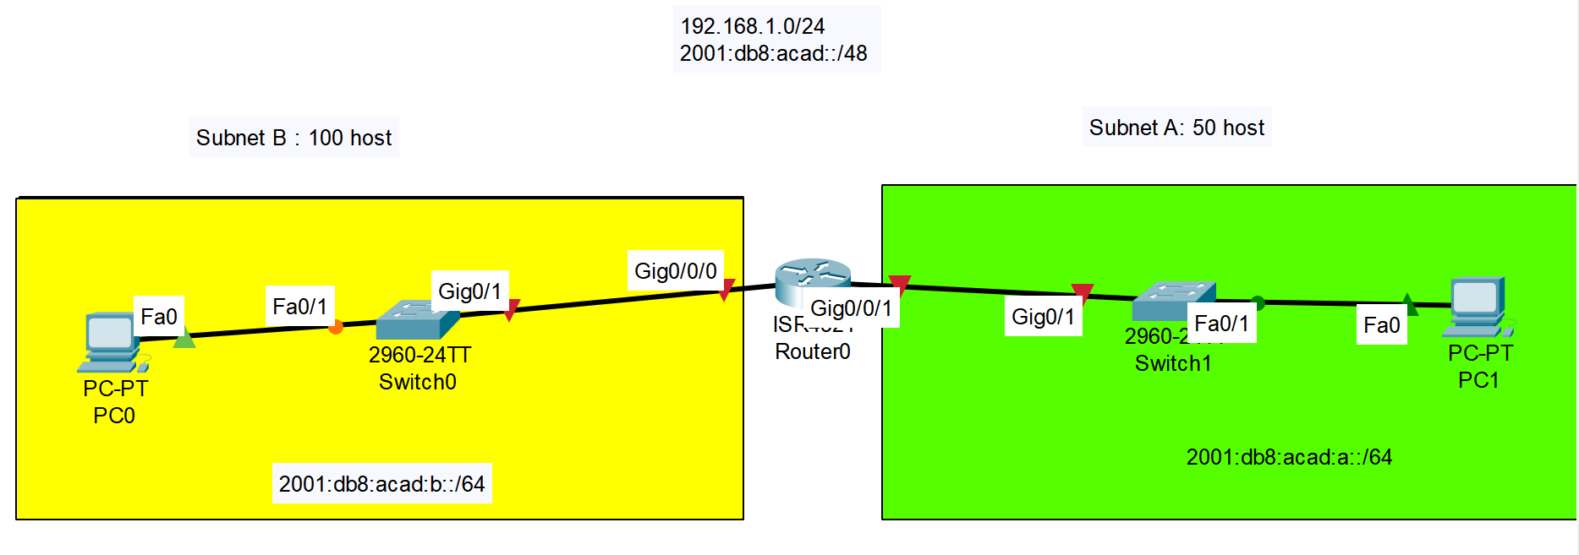

# Background /Scenario

**Note**: This activity is best completed in groups of 2-3 students.

Design and build a network from scratch.

* Your design must include a minimum of one Cisco 4321 router, two Cisco 2960 switches, and two PCs.
* Fully configure the network and use IPv4 or IPv6 (subnetting must be included as a part of your addressing scheme).
* Verify the network using at least five show commands.
* Secure the network using SSH, secure passwords and console passwords (minimum).

Create a rubric to use for informal peer grading. Present your Capstone Project to the class and be able to answer questions from your peers and Instructor!

# Required Resources

* Packet Tracer
* Student/group-created rubric for assessment of the assignment

# Reflection

* 1. What was the most difficult portion of this activity?

Type you answers here.

* 1. Why do you think network documentation is so important to this activity and in the real world?

Type you answers here.

End of document